**Quiz - Section 9.3 – Les relations linéaires**

**Q1) b)**

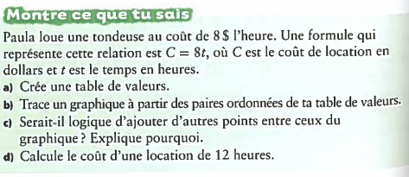



**a)**



|  |  |
| --- | --- |
|  |  |
|  |  |
|  |  |
|  |  |
|  |  |



**c)**



**d)**



**Quiz - Section 9.3 – Les relations linéaires**



**Q1) b)**



**a)**

|  |  |
| --- | --- |
|  |  |
|  |  |
|  |  |
|  |  |
|  |  |

**c)**

**Q2)**

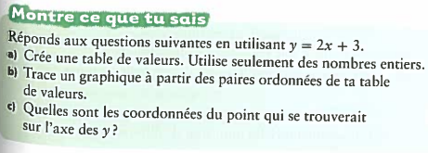**b)**



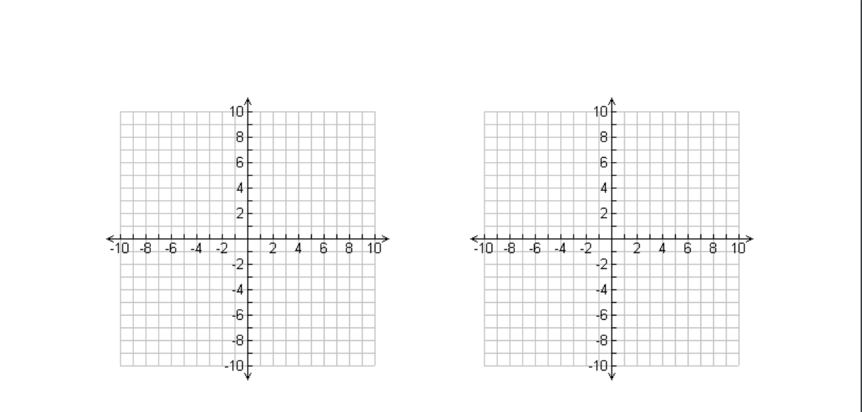**a)**



|  |  |
| --- | --- |
|  |  |
|  |  |
|  |  |
|  |  |
|  |  |

**c)**



**Q2)**

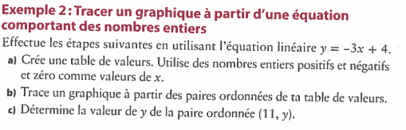

 **b)**



**a)**



|  |  |
| --- | --- |
|  |  |
|  |  |
|  |  |
|  |  |
|  |  |

**c)**

