**Quiz - Section 9.3 – Les relations linéaires /7**

**Q1) b)**

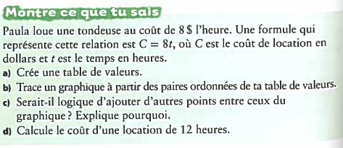

**a)**

|  |  |
| --- | --- |
|  |  |
|  |  |
|  |  |
|  |  |
|  |  |

**c)**

**d)**

**Quiz - Section 9.3 – Les relations linéaires /7**

**Q1) b)**



**a)**

|  |  |
| --- | --- |
|  |  |
|  |  |
|  |  |
|  |  |
|  |  |

**c)**

**d)**

**Q2)**

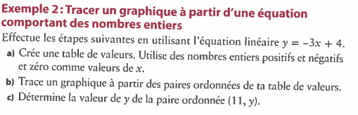**b)**

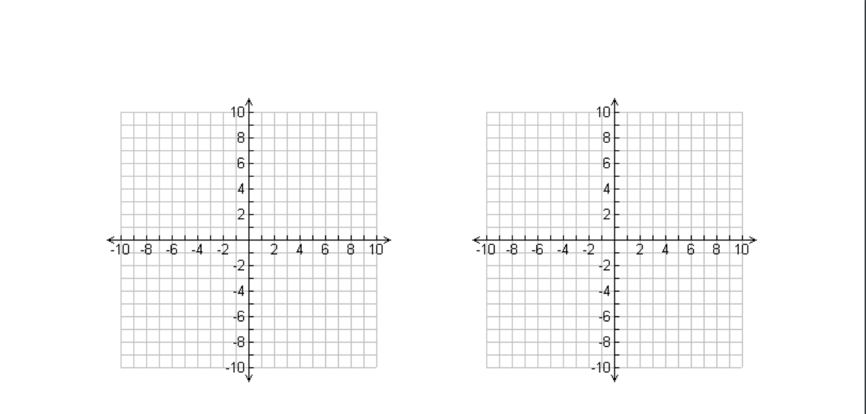



**a)**



|  |  |
| --- | --- |
|  |  |
|  |  |
|  |  |
|  |  |
|  |  |

**c)**



**Q2)**

**b)**



**a)**



|  |  |
| --- | --- |
|  |  |
|  |  |
|  |  |
|  |  |
|  |  |

**c)**

