Nom:_______________________
Date:______________________

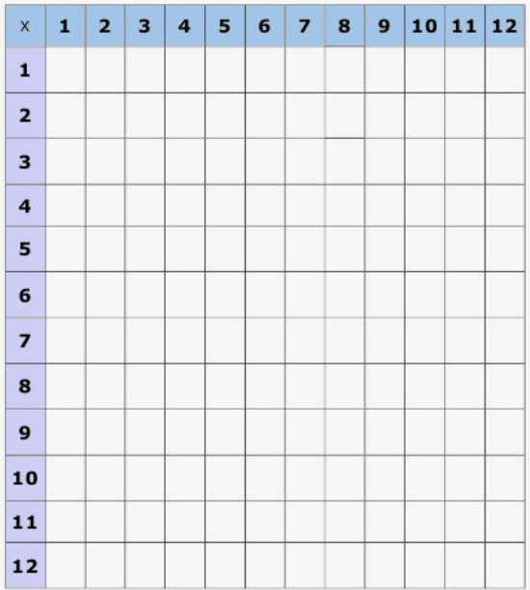

Nom:_______________________
Date:______________________

